**Rest Jersey Demo.**

Step-1 Open Chrome Advance Rest Client.

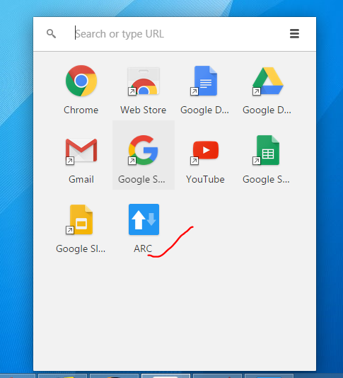

Step-2 provide fetch user details URL using GET Request.

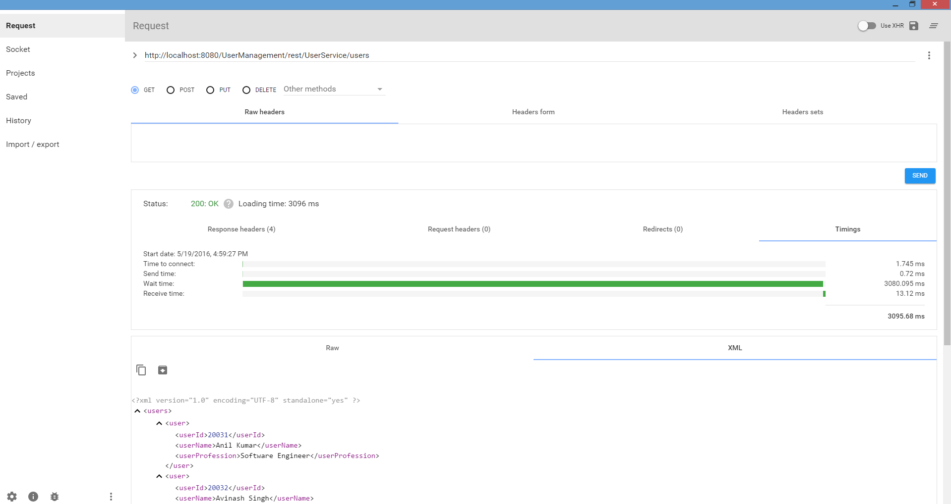

Step-3: provide save URL using POST Request.

